

***2025 Safety Manual***

***Butte, Montana***

***Montana District 2***

***League ID 314905***

Contents

MISSION/FACILITIES 3

MISSION 3

FACILITIES 3

BOARD OF DIRECTORS/EMERGENCY CONTACT INFORMATION 4

CHILD PROTECTION AND VOLUNTEER BACKGROUND CHECKS 5

FUNDAMENTALS 5

FIRST AID and CONCUSSION POLICY 5

CONCUSSION POLICY 5

CONCUSSION PROTOCOL 6

REPORTING INJURIES 7

FACILITIES AND EQUIPMENT 7

STORAGE SHED PROCEDURES 8

CONCESSION STAND PROCEDURES 8

PLAY BY THE RULES 9

ADDRESSING COMPLAINTS & GRIEVANCES 9

APPENDIX 11

APPENDIX A: LITTLE LEAGUE BASEBALL AND SOFTBALL ACCIDENT NOTIFICATION FORM 11

APPENDIX B: LITTLE LEAGUE VOLUNTEER APPLICATION FORM-2025 13

APPENDIX C: CONCUSSION INFORMATION SHEET FOR PARENTS 14

## MISSION

Our mission is to create a city- wide girls softball program. The goal of the program is to provide quality instruction at all levels while focusing on sportsmanship, teamwork, competitiveness, and fair play. The league will be committed to fostering the love of the game in a positive, competitive environment.

## FACILITIES

In cooperation with Park and Recreation Department of Butte-Silver Bow, Copper City Softball Little League uses the following facility:

Longfellow Complex (Cleveland Street and Kennedy Ave)

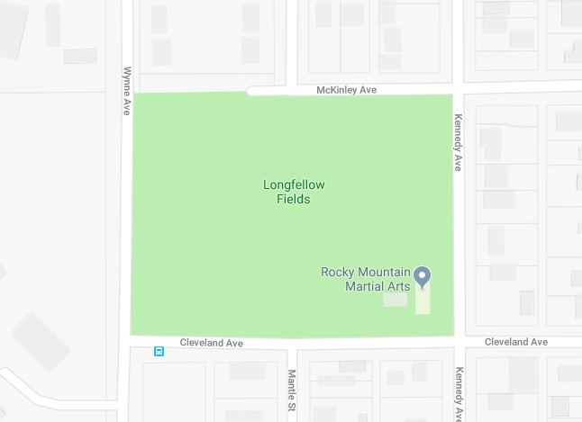

Copper Mountain Sports and Recreation Complex – Field #2 (80 Beef Trail Rd)

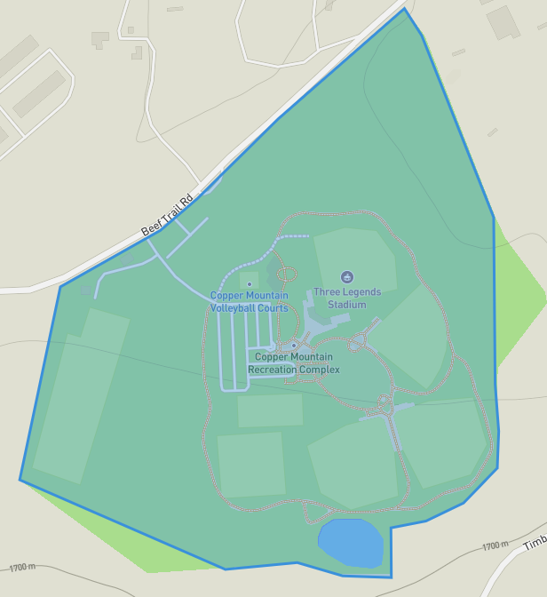

Information about the conditions and features of these facilities are available in the League Facility Survey.

# BOARD OF DIRECTORS/EMERGENCY CONTACT INFORMATION

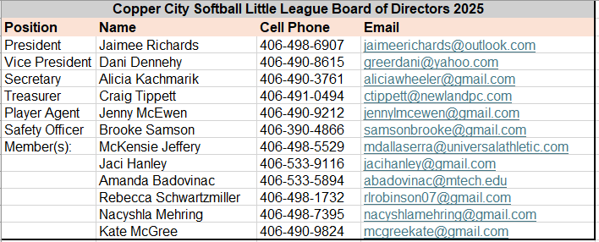

**Emergency Contact Procedures**

1. Dial 911
2. Give dispatcher the necessary information when asked. Some common questions include

**Field Location:** Longfellow Fields. Cross streets of Cleveland Ave., Wynne Ave., Kennedy Ave.

**What Happened?**

**How many people are involved?**

**Your name and number in case you get disconnected?**

**Status of victim including aid being administered**

1. DO NOT HANG UP. Send someone to look for emergency Personnel

**Page is posted in Clubhouse and Concession stand**

# CHILD PROTECTION AND VOLUNTEER BACKGROUND CHECKS

The safety and well-being of Little Leaguers is paramount and at the forefront of all that the Copper City Softball does. Any person that interacts with players will need to perform a background check and will also need to complete the required annual Abuse Awareness Training to prevent and educate volunteers on all types of abuse. The background check and abuse training must be completed before any individual can assume any duties for the current season. This will include Coaches, Managers, Parent Helpers, Umpires, etc. Copper City Softball Little League will abide by and adhere to the official Little League Child Protection Program, and will have zero tolerance to infractions of this program.

When registering, the ability to sign up as a volunteer is available. Data collected through Blue Sombrero is used to conduct background checks and track volunteers. Any person volunteering for Copper City Little League needs to create and account and register with the league.

Information provided by users when registering for volunteer positions is automatically sent to JDP for background processing.

It is the responsibility of the volunteer to complete the annual Abuse Awareness Training and provide proof of completion to the league.

Abuse Awareness Training is available online through the official Little League website at: <https://www.littleleague.org/player-safety/child-protection-program/safesport-resources-parents/>

Little League’s Child Protection Program can be found at: <https://www.littleleague.org/downloads/ll-child-protection-program/>

Status of volunteers are kept within the league database within Blue Sombrero.

**For any volunteers not in the system, they will be required to fill out the Little League Volunteer form shown in Appendix B of this document and provide it to a board member for processing. Blank forms will be available in the clubhouse.**

# FUNDAMENTALS

Copper City Softball believes that one of the best ways to prevent injuries and accidents is to have the players be taught proper fundamental skills of softball. All Managers and coaches are required to attend a fundamentals clinic hosted by the league. Several different experts have served as instructors.

This year’s fundamentals workshop is scheduled for Sunday, April 13 and will include First Aid, Concussion and AED training.

# FIRST AID and CONCUSSION POLICY

Copper City Softball believes that preventing and being able to respond to medical situations is the cornerstone of any safety plan. Whether it be on the field or off the field, leagues can help not only prevent accidents, but educate youngsters in fundamental safety concepts that can help them safe on and off of the field. CCSLL managers are required to take one practice before games begin to discuss bicycle and motor transportation, bullying, and tobacco avoidance. The speed limit on CCSLL facilities is 10 mph as it is posted by county officials. CCSLL requires that all umpires, managers and coaches attend a first aid/accident prevention clinic in order to stay current with first aid procedures. Clinic will be held on Monday, April 7 at CCSLL facility. Each team is issued a first aid kit and is required to have it at all practices and games. First aid kits are also available at all facilities.

An AED, or automated external defibrillator, is used to help those experiencing sudden cardiac arrest. It's a sophisticated, yet [**easy-to-use**](https://www.redcross.org/take-a-class/aed/using-an-aed/aed-steps), medical device that can analyze the heart's rhythm and, if necessary, deliver an electrical shock, or defibrillation, to help the heart re-establish an effective rhythm. AED will be available at the clubhouse facility. AED training will be provided to coaches at annual safety clinic on April 7.

Electronic weather detector application WeatherBug should be used by league officials and coaches to monitor weather during practices and games. Suspension of activity is required when the storm is detected at 3 to 8 miles away. Games will be suspended for 20 minutes to ensure the storm has moved out. Children should be removed from metal dugouts and seek shelter while in delay.

## CONCUSSION POLICY

A concussion is a type of traumatic brain injury that interferes with the normal function of the brain. It occurs when the brain is rocked back and forth or twisted inside the skull because of a blow to the head or body. The blow does not need to be directly to the head for a concussion to occur. What may appear to be only a mild jolt or blow to the head or body can result in a concussion. It is now known that young athletes are particularly vulnerable to the effects of a concussion and that a concussion has the potential to result in short or long-term changes in brain function, or in some cases, death. There is no such thing as a minor brain injury. Any suspected concussion must be taken seriously and acted upon immediately. Recognition and Management If an athlete exhibits any signs, symptoms, or behaviors that make you suspicious that he or she may have had a concussion, that athlete must be removed from all physical activity immediately! Continuing to participate in physical activity after a concussion can lead to worsening concussion symptoms, increased risk for further injury, and even death.

Concussion training is available online through the Centers for Disease Control at <https://www.cdc.gov/headsup/youthsports/training/index.html>

Each head coach and each board member will be required to submit a copy of the certificate once completed and must be done before the first game of the season.

The handout in Appendix A will be given to all parents to raise awareness of concussions. The form is also available at <https://www.cdc.gov/headsup/pdfs/youthsports/Parent_Athlete_Info_Sheet-a.pdf>

## CONCUSSION PROTOCOL

Managers, coaches, umpires, and league officials are not expected to be able to “diagnose” a concussion. That is the role of an appropriate health-care professional. However, you must be aware of the signs, symptoms, and behaviors of a possible concussion, and if you suspect that an athlete may have a concussion, then the following procedure must be enacted immediately:

1. Immediately remove the athlete from game/practice/physical activity.**

2. Complete the CCSLL Concussion Checklist immediately upon removal from game/practice/physical activity. Turn completed form into appropriate CCSLL official. If the health status of the athlete warrants immediate medical assistance/attention (seizure, loss of consciousness, etc.) call 911 immediately and then complete a concussion checklist when the situation allows you to do so.

3. The signs, symptoms, and behaviors of a concussion are not always immediately apparent after a bump, blow, or jolt to the head or body and may develop over a few hours. An athlete should be observed following a suspected concussion and should never be left alone.

4. Inform the athlete’s parents or guardians about the possible concussion and inform them that CCSLL policy mandates that the athlete must be evaluated by an appropriate health-care professional and will not be allowed to return to practice or games until an appropriate health-care professional says they are symptom free and medically clears them to resume physical activity.

5. Manager/coaches will not allow athletes to resume practice/games/physical activity until they are provided a written release by the athlete’s health care provider. Verbal indication of release by parent/guardian is not acceptable – written release must be provided and this in turn must be into appropriate league official to be filed with other documentation of incident.

** In the event that a manager or coach becomes aware (i.e., disclosure by parent/guardian/ player) that a player has been involved in a non-league activity that is known to have actually caused a concussion or is of such a nature as to cause concern – the manager /coach is to restrict league activity until such time as the player is examined and released by an appropriate health care professional to return to full physical activity. When in doubt, sit them out!

Important to Remember: If an athlete returns to activity before being fully healed from an initial concussion, the athlete is at risk for a repeat concussion. A repeat concussion that occurs before the brain has a chance to recover from the first can slow recovery or increase the chance for long-term problems. In rare cases, a repeat concussion can result in severe swelling and bleeding in the brain that can be fatal. Athletes must know that they should never try to “tough out” a suspected concussion. Teammates, coaches, umpires, and parents/guardians should never encourage an athlete to “play through” the symptoms of a concussion. In addition, there should never be an attribution of bravery to athletes who do play despite having concussion signs or symptoms. The risks of such behavior must be emphasized to all members of the team, as well as coaches and parents.

## REPORTING INJURIES

1. Report incident immediately to League Official
2. Fill Out Accident Claim form. Forms are available in Appendix A of this Document, or at the clubhouse.
3. Once completed by Parent and League, form will be submitted to Little League International.

## 

# FACILITIES AND EQUIPMENT

Managers, Coaches, and Umpires are required to inspect equipment on a regular basis. The League Safety Officer will inspect equipment prior to each season. Managers, coaches, and umpires will inspect equipment prior to each game. Equipment not fit for use will be destroyed so that an individual can’t use them again to prevent someone to use it without league knowledge. Breakaway bases are used on all fields. In addition, the league equipment supervisor will also manage the storage sheds at the facilities to ensure they are organized, and maintenance equipment is safely stored.

Managers, coaches, and umpires must inspect the field prior to use. League officials must also inspect facilities as well. Inspections of league officials, managers, coaches, and umpires’ areas essential to their use.

Items included in either inspection by league officials, managers, coaches, and umpires include:

1. Holes, damages, rough, or uneven spots.

2. Slippery areas and long grass.

3. Glass, rocks, and other debris and foreign objects.

4. Unsafe conditions around backstop and pitcher’s mound.

5. Warning track condition.

6. Dugout conditions before and after games. Teams are required to clean the dugout after use.

7. Availability of telephone.

8. Area around the bleachers is free of debris.

9. Garbage clean-up

10. Establishing who is in charge of the facility that game.

11. Restroom conditions.

12. Concession stand inspection.

Disengage-able bases will be used on all fields. The speed limit for all cars at all facilities is 5 mph. Items such as mouthguards, faceguards for helmets, and pitcher heat protectors are available for players, parents, managers, or coaches that requests them. Parents are welcome to make suggestions to the President or Safety Officer at any time. All adults are encouraged to sign-up for Little League E-News in order to keep up with current practices, suggestions, and trends in safety development for participants.

## STORAGE SHED PROCEDURES

The following applies to all of the storage sheds used by CCSLL and apply to anyone who has been issued a key by CCSLL to use those facilities.

1. Keys are available through the President who keeps record of key disbursements. All keys must be returned at the end of the season.

2. All individuals with keys to CCSLL equipment and storage sheds are aware of their responsibilities for the orderly and safe storage of rakes, shovels, bases, etc.

3. All individuals are responsible to read operating instructions for all equipment prior to use. (I.e. lawn mowers, weed whackers, lights, scoreboards, pa systems, etc.)

4. All chemicals or organic materials stored in CCSLL sheds shall be properly marked and labeled as to its contents. Material Safety Data Sheets will be available for all materials requiring them. Sheets will be stored in office as well as where the chemical is stored.

5. All chemicals organic materials stored within these sheds will be separated from areas used to store machinery and gardening equipment to minimize the risk of puncturing storage containers.

6. Any witnesses “loose” chemicals organic materials within these sheds should be cleaned up and disposed of as soon as possible to prevent accidental poisoning.

7. Cleaning supplies will not be stored in concession areas.

8. Adults are responsible to clean storage shed after each use.

# CONCESSION STAND PROCEDURES

CCSLL recognizes the important role that concession stands have in supporting the overall program. It is essential for concession stand procedures to provide safe items to league supporters.

Procedures will be posted at all concession stands.

1. Menus are very simple to minimize cooking equipment and maintenance. Food items must come from approved sources. Control of items is supervised by league from purchase to sale. Safety Officer must approve menus.

2. Thermostats are used to maintain proper levels of cooked materials. Foods must be properly stored at the correct temperature.

3. Reheating food items is not practiced. Potential left over potentially hazardous foods must be discarded each night.

4. Proper cooling facilities (under 41 degrees) must be available if food is to be stored.

5. Hand washing is the first line of defense in preventing food borne diseases.

6. Foods that have potential allergic implications (ie nuts) must be labeled and knowledge of contents understood by worker.

7. Workers that are healthy are the only ones that will prepare foods. Use of protective gloves and hair covering items must be available.

8. Disposable utensils are recommended. Utensils that must be washed need to be washed in hot soapy water, rinsed in clean water, and air dried. Use of chemical or heat sanitizing equipment is also recommended.

9. Ice for injuries needs to be placed in plastic bags and stored separately. Avoid touching ice with hands.

10. Wiping cloths are to be stored in a bucket of sanitizer and changed every two hours.

11. Food and utensils need to remain covered to protect from insects. Frequent sweeping of floors is also effective way of preventing insects.

12. Food needs to be stored at least six inches above the ground.

13. Workers under the age of 14 must be supervised by an adult.

14. Proper smoke detectors and fire extinguishers are installed in each concession stand.

# PLAY BY THE RULES

CCSLL operates under the Official Rules and Regulations of Little League Softball. Local rules that are provided by such rules will be provided in writing to the managers, coaches, and umpires. The league is dedicated to recruiting and providing education for umpires. Training includes using resources such District Consultants and Regional Umpire Schools when appropriate dedication is established. Managers, Coaches, Umpires are required to attend annual rules clinic conducted by District Umpire Staff. The clinic this year will take place on Sunday, April 6 from 12:00pm-3:00pm at Longfellow Fields. It is essential that deviation from the rules as a significant number of the rules are established in order to make the game safer. These include, but aren’t limited to

* scheduling procedures
* no on-deck batters
* coaches not allowed to warm up pitchers (including standing at the backstop)
* Use of disengaging breakaway bases.

# ADDRESSING COMPLAINTS & GRIEVANCES

As in any competitive situation, there are always times that individuals will disagree with the decisions made by an organization and its leaders. A truly safe program allows for those disagreements to be heard in a safe, non-threatening manner. As an entity that employs volunteers, the organization must respect due process rights of individuals involved in decisions of the organization. Thus, a method of bringing forward complaints is necessary in order to protect the due process and dignity of individual members, as well as providing a safe method by which members can relate their feelings on decisions, etc. without turning into a crisis situation. Referring to the League Code of Ethics will be of great assistance to league personnel throughout a grievance situation and should be referred to during the process.

The first step of any grievance is to attempt to handle the situation unofficially through mediation. Note: All player complaints are represented through the Player Agent who speaks on behalf of players. The complaining party is required to contact the individual directly to verbally voice the complaint. If no solution is found, the division director may be brought into conversation. If no solution is found, the President may be contacted. Both parties must contact the President to ensure the need for his or her involvement. If the President cannot mediate the situation to a solution, he or she will ask the complaining individual to put the complaint in writing in which the complaint will be heard at next Board meeting or at special meeting if the President feels the issue is of dire attention. All complaints must be in writing to be heard by the Board. The Board of Directors will then listen to complaint as well as responses from other parties and offer solutions. The League Constitution spells out timelines for resolving these complaints. Complaints about personality conflicts will not be heard by the Board unless it shows negative impact on the kids shows negative impact on the kids.

# APPENDIX

# APPENDIX A: LITTLE LEAGUE BASEBALL AND SOFTBALL ACCIDENT NOTIFICATION FORM

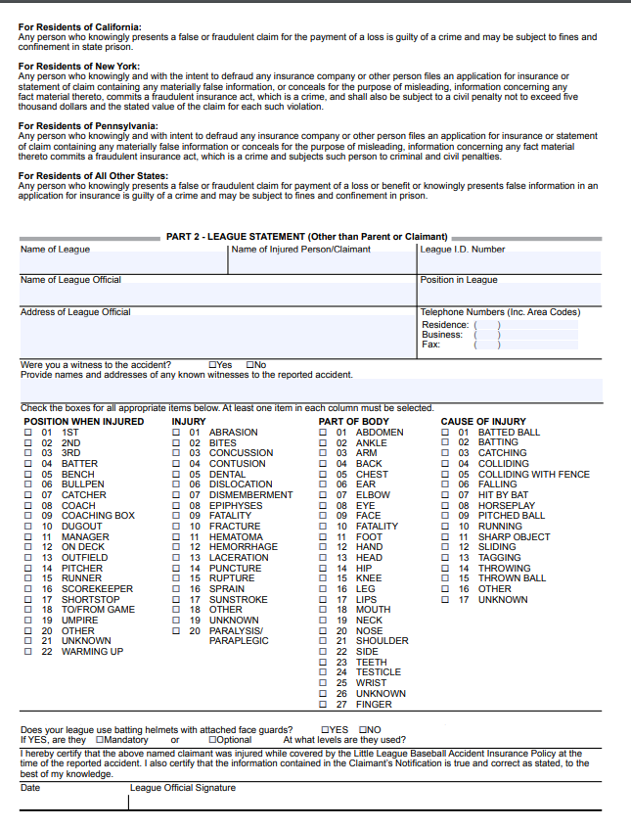

## 

## APPENDIX B: LITTLE LEAGUE VOLUNTEER APPLICATION FORM-2025

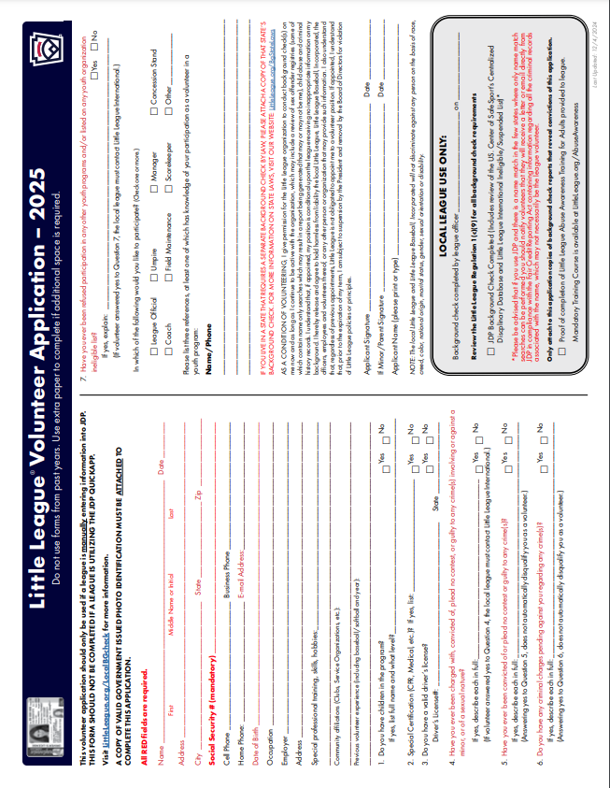

## APPENDIX C: CONCUSSION INFORMATION SHEET FOR PARENTS

